Appendiceal Carcinoid
Stem: A previously healthy 68-year-old woman is seen in the ED with 18 hours of RLQ abdominal pain and CT findings showing acute appendicitis without perforation, abscess, or phlegmon. You proceeded with laparoscopic appendectomy, patient does well and goes home on POD 1.
Now she is in the clinic for post op, the pathology report had just been signed and released while she was waiting to be roomed. When you walk in to see her, she is obviously distressed and asking you “What is the plan, pathology is showing “tumor”” … She is crying.
Laparoscopic or Open Appendectomy (Describe

You pull the pathology report, and it shows …
- 6mm well circumscribed carcinoid tumor near tip of appendix with no lymphovascular invasion or evidence of perforation ?
  - Reassure, Nothing further
- Path Returns with 14mm well carcinoid tumor at mid appendix with lymphovascular invasion

- PET-Dotatate or Octreotide scan post op, with tumor markers
- Right Colectomy (Describe)
-Open , lap or robotic
- Examine peritoneal surfaces, liver.
- Mobilize the right colon from lateral to medial or medial to lateral
- Enter lesser sac at hepatic flexure.
- separate omentum from transverse colon.
- Divide mesentery.
- Ligate ileocolic vascular pedicle. (Could be done before mobilizing the colon especially with medial to lateral mobilization) -
- Construct ileocolic anastomosis.
- Close mesenteric defect (surgeon preference).

- Path Returns with 34mm well-circumscribed carcinoid tumor at mid appendix without evidence of perforation or lymphovascular invasion.

  - Right colectomy
4. Pathology returns with adenocarcinoma:

  - Stage the patient with CT C/A/P
  - CEA level
  - Colonoscopy if no recent one
  - Right colectomy
- What if, there is a mucinous mass involving the base of the appendix. During mobilization and right colectomy there is spillage of mucin. What next?
Referral for evaluation for HIPEC.

GIST

Stem: A 70yoF presents to your office with complaints of 4 months of early satiety. She denies any nausea/emesis, constipation, denies hematechezia or hematemesis. Last colonoscopy 5 years ago, normal. She endorses a 10lb weight loss in the same amount of time

PMHx: hyperlipidemia, hypertension

PSHx: inguinal hernia repair 30 years ago

Meds: metoprolol, cholesterol med, baby aspirin

SocHx: social drinker; 20 pack year history smoker, quit 20 years ago

FH: Non-contributory

Vital Signs: BP 142/85 HR 75 99% on room air

PE: well appearing female although thin. Abdomen soft, nontender with palpable left upper abdominal mass. No associated lymphadenopathy

How would you work up this patient?

Work up:

CT abd/pelvis with IV/PO contrast – 7cm heterogenous mass associated with the gastric fundus without evidence of liver or peritoneal metastases or adenopathy

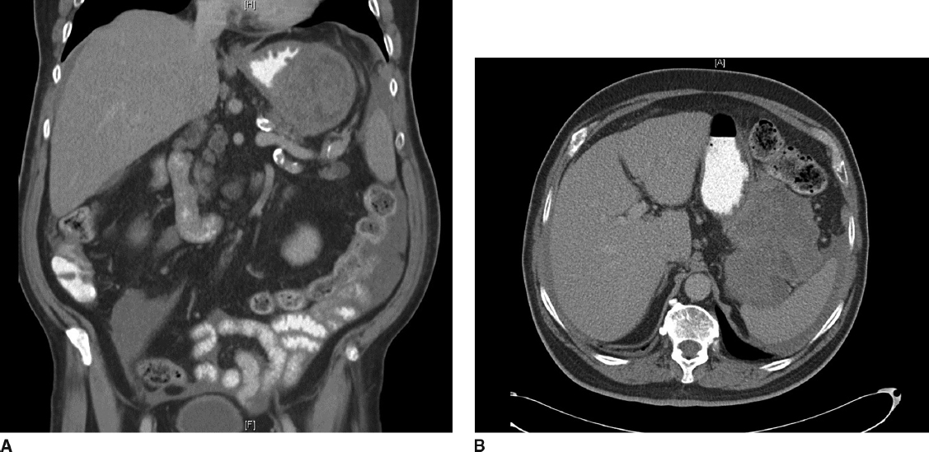

Diagnosis:

Gastrointestinal stromal tumor

What would you like to do next?

EGD (Describe)

Procedural sedation

Place in left lateral decubitus position

Insert scope into mouth under direct visualization

Pass the scope past the cricoarytenoid cartilage into the esophagus

Ensuring direct visualization, pass the scope through the esophagus with continuous insufflation in order to visualize the entire esophagus

Visualize the gastroesophageal junction and pass into the stomach

EGD demonstrates large submucosal mass without any ulceration.

If examinee asks for :
- biopsy: no pathologic abnormality
- EUS: large heterogenous mass contiguous with gastric wall without perigastric lymphadenopathy
- FNA: spindle cells, immunohistochemistry not performed. (FNA not necessary unless concerned for metastatic spread, unresectable or neoadjuvant therapy is planned)
- MRI or PET – not available

How would you treat this patient?

Resectable GIST. No neoadjuvant therapy is necessary

Describe operative approach:

Can perform laparoscopically or open.
- If laparoscopic:
  - need to describe position and port placement: lithotomy or supine position
  - 12mm port to the left of the umbilicus.
  - 4 additional ports – right of umbilicus, right costal margin, left costal margin and liver retractor

- Open – supine position, upper midline celiotomy
  - Examine the abdomen for metastases
  - Resect the GIST with 1cm gross margin utilizing staple device, ensuring not to narrow the gastroesophageal junction.
  - Should use endoscopy or bougie to ensure against narrowing of stomach or GE junction.
  - Should perform leak test
  - Ensure not to disrupt the pseudocapsule and cause spillage of tumor

Pathology returns as 7cm gastrointestinal stromal tumor with mitotic rate >50/HPF, Any other recommendations for this patient’s care?

Imatinib for at least 3 years

H&P as well as CT scan every 6months-1 year for at least 10 years

EQ1 Cholecystectomy Complications
Stem: You are called to the ER to see a 65-year-old man who presents with worsening epigastric and RUQ abdominal pian, 3 days after laparoscopic cholecystectomy for acute, calculous cholecystitis.
Reports, PO intolerance, chills, fevers, jaundice, darkened urine.
He is otherwise without significant past medical or surgical history.
Vitals : HR 114bpm, BP 94/37; 94% on RA, 38.8C
PE: Ill appearing, lethargic, jaundice, scleral icterus Mildly distended, TTP in the RUQ and epigastrium.
labs: WBC 16.4k; Tbili 4.3; AST 143; ALT157; ALK Phos 312; Creatinine 1.73 (normal 0.90)

Stem: You are called to the ED to see a 78 yo man who presents with 3 day history of fevers and chills, sweats and feeling poorly. He reports RUQ abdominal pain and some nausea but no emesis. He is otherwise healthy.
Vitals: T=99.9 degrees, BP=100/60, HR 110, and RR of 20.
Physical exam : Tender to palpation in the right upper quadrant without guarding or peritoneal signs.
Labs: WBC of 18K, LFTs slightly elevated, otherwise rest of labs normal.
PMH/PSH: Diverticulitis. Colonoscopy 1 year ago with diverticulosis

What’s the initial study would you like to order now?
RUQ US –dilated intra and extrahepatic bile ducts with CBD measuring 1.1cm, mild RUQ fluid, and distal common bile duct stone.

How are you going to manage this patient.
- Sepsis workup.
- Resuscitation / hydration/ antibiotics.
- ERCP : You are not credentialed to do it and your GI colleague is on vacation.
- PTC: Your IR colleagues are not available
- Urgent CBD exploration:
  - Open CBD Exploration.
  - Kocherize the duodenum, palpation of the common bile duct to assess location/mobility of the stone, exposure of anterior CBD
  - Place sutures at the 10 and 2 positions and make an anterior vertical ductotomy.
  - Flush duct with small diameter red rubber and pass a biliary Fogarty catheter proximally and distally until all stones are removed.
  - Choledochoscope can be used with wire basket to retrieve challenging stones.
  - Close ductotomy over a 14 fr T-tube
  - Perform completion cholangiogram.
  - Leave JP drain.

Scenario 2: Same patient arrives, RUQ US notes intra and extra hepatic ductal dilation, mild fluid, no stone is appreciated. You are now in a tertiary center with all images and expertise available.
- ERCP or MRCP or advanced imaging to delineate etiology → 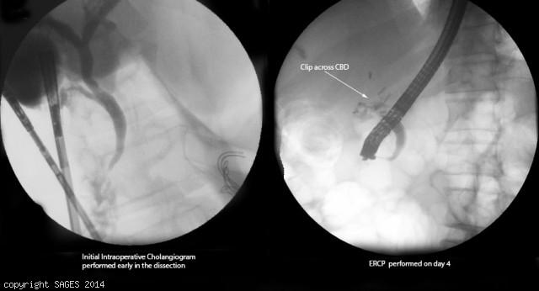
Concern for clip across CBD
- Antibiotics
- IR consultation for PTC.
You take the patient to the OR for repair, how do you repair the following?
- Injury < 50% circumference, not caused by cautery - Repair over T tube.
- Transection < 1 cm in size and away from bifurcation - End to end anastomosis.
- More severe injury, or close to the bifurcation: Hepaticojejunostomy -- Describe.
  - Identify CBD
  - Place two traction sutures on either side of the dilated bile duct.
  - The distal CBD is ligated.
  - The duct is divided below the traction sutures.
  - The end of the common duct is then trimmed to achieve maximal diameter.
  - fashion a Roux-en-Y jejunal limb
  - This limb is identified and transected with a stapling device 30-35 cm from the ligament of Treitz.
  - A single-layer anastomosis can be performed by a side-to-side anastomosis to the Roux limb
Scenario 3: Same patient however with AST/ALT and Alk phos within normal limits, Tbili slightly elevated to 2.4. RUQ US shows concern for large fluid collection in the RUQ.
1. HIDA: Shows biliary leak.
2. ERCP obtained → cystic duct stump leak confirmed → Sphincterotomy and Stent
3. IR for drainage of RUQ fluid collection if symptoms do not resolve, persistent leakage or septic.

